# ABC Inventory Management

# Test Scenario: Beta Test Scenario 2

Table of Contents

ABC Inventory Management 1

Test Scenario: Beta Test Scenario 2 1

Scenario Description 3

Version Control 3

Test Scripts 3

Use Case 3

Test Components/ Requirements 3

User Groups 3

Test Scripts 3

ES001: Edit Staff Details (Manage Staff) Script 3

Script Description 3

Testing Requirements 4

Setup 4

Teardown 4

Script Steps 4

Result Screenshots 5

LI001 Login Script 6

Script Description 6

Testing Requirements 6

Setup 7

Teardown 7

Script Steps 7

Result Screenshots 7

# Scenario Description

This scenario is intended to test a business condition when the warehouse receives order of a product size delivered from the manufacturers which needs to be added to the system. The warehouse receives a delivery of 15 of the J3 product in size XS. These products and product size already exist in the system. Moreover, a warehouse staff must then send 5 of the J3 product in size XS to Epping Store and 5 to Oxford Store. It is assumed that all paper works and physical handling and counting of the products are done by the warehouse staff after which he/she proceeds to enter it to the system.

# Version Control

|  |  |  |  |
| --- | --- | --- | --- |
| Version Number | Date | Author | Description |
| 12.0 | 02/10/2018 | Shirish Maharjan | Initial Draft |
| 12.1 | 03/10/2018 | Shirish Maharjan | First Version (Iteration 6) |

# Test Scripts

The following are the test scripts that will cover this scenario:

* API001 Add Product Item (Manage Product) Script
* SP001 Send Product Script

# Use Case

The use case covered by this test scenario is as follows:

* Add Product Item under Manage Product
* Send Product

# Test Components/ Requirements

This test scenario covers the following high-level testing requirements:

* Manage Product (Add Product Item) Functionality of the system
* Send Product Functionality of the system

# User Groups

* Anonymous User 1

# Test Scripts

The following are the elaboration of the test script mentioned above:

# API001: Add Product Item (Manage Product) Script

## Script Description

This script follows each step while a warehouse user adds new products J3 of size XS to the warehouse after he/she receives it physically through a delivery from the manufacturers. If any step fails to succeed, a bug will be reported, and the test will be conducted again.

## Testing Requirements

This test will cover the Manage Product (Add Product Item) Functionality of the system.

## Setup

* The computer in the location is powered on.
* Make sure the computer is connected to the internet.
* Application is launched.
* Warehouse Staff username and password are known.
* Items are counted physically once received from the manufacturers.

## Teardown

* 15 J3 products of size XS are added to the warehouse.

## Script Steps

|  |  |  |  |
| --- | --- | --- | --- |
| Step | Test Action | Expected Results | Pass/Fail |
| 1. | Application is launched. | System displays the ‘Login’ Page with the Username and Password field empty. | Pass |
| 2. | Warehouse staff enters username and password in the username and password field. | System waits till user to click on ‘Login’ button. | Pass |
| 3. | Click on the ‘Login’ button. | System grants access to the user and opens the Homepage. | Pass |
| 4. | Click on the ‘Manage Product’ button. | System displays the Manage Product page. | Pass |
| 5. | Enter J3 which is the product code on the search field. | System waits for user to perform any action. | Pass |
| 6. | Click on the ‘Search’ icon. | System searches for the product entered in the database and displays the product details like name, price and description. | Pass |
| 7. | Click on the ‘Add Product Item’ icon for the product. | System displays the ‘Add Product Item’ screen and waits for user to enter the product size details. | Pass |
| 8. | Enter the values like size, quantity and location. | System waits for user to perform any action. | Pass |
| 9. | Click on ‘Add’ button. | System adds the product size to the location entered in the database and displays an appropriate message. | Pass |

### Result Screenshots

**Step 1**

Application launched, and login page is displayed.

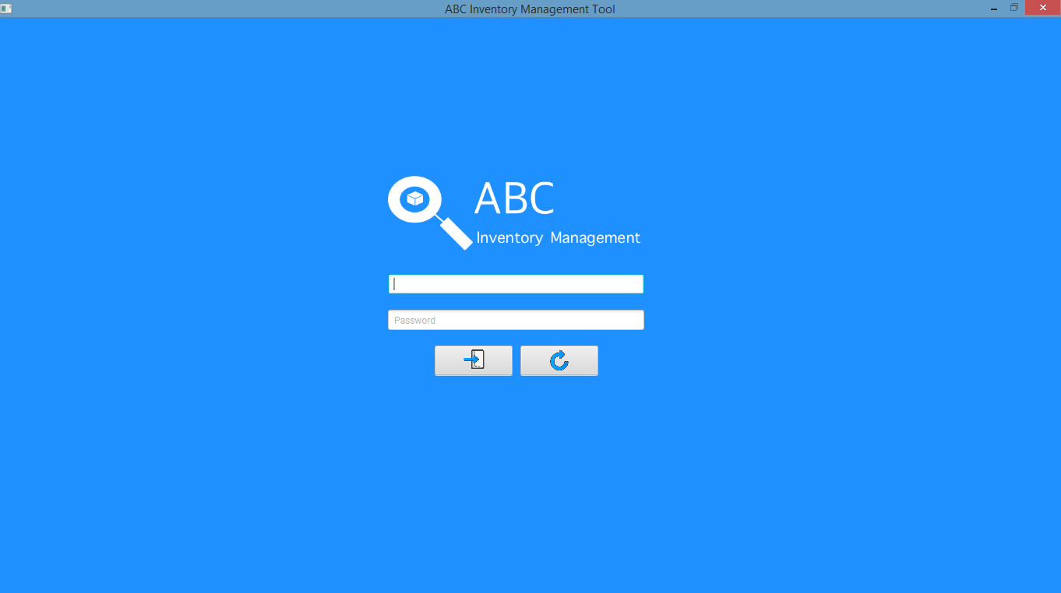

**Step 2**

Username and password are entered, and the system waits user to click on the ‘Login’ button.

**Step 3**

After the ‘Login’ button is pressed at step 2, access is granted, and the Homepage is displayed.

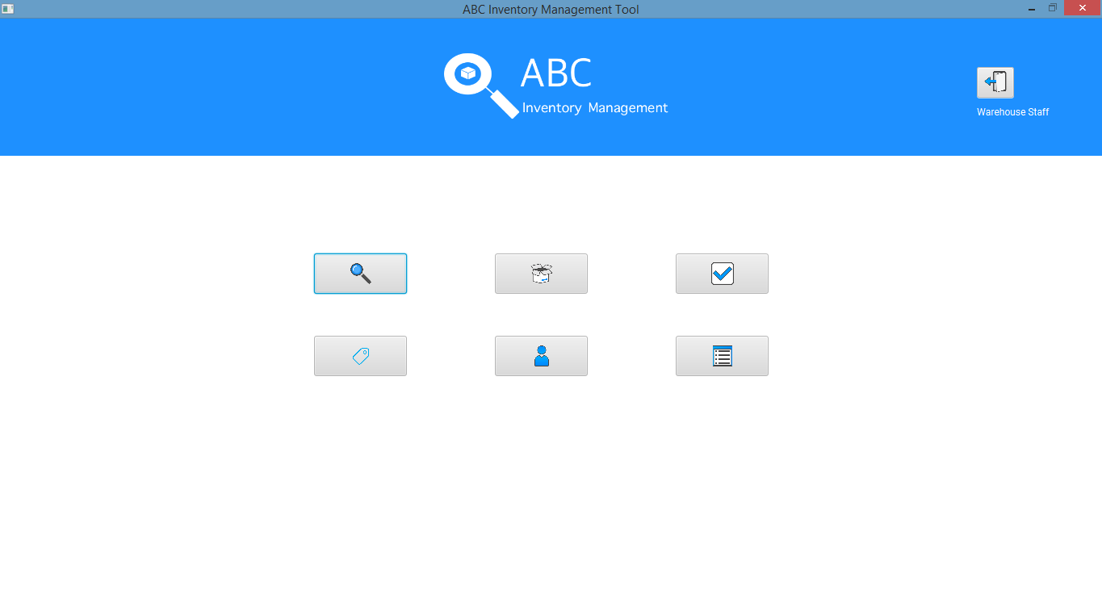

**Step 4**

**Step 5**

**Step 6**

**Step 7**

**Step 8**

**Step 9**

**Step 10**

**Step 11**

**Step 12**

# SP001 Send Product Script

## Script Description

This script follows each step while a warehouse staff sends 5 of the newly added size XS of the product J3 to each stores. It is assumed that the warehouse staff will pack the products and send the products through an external delivery service after sending it through the system. This script will check if each step while sending the product is a success. If any step fails to succeed, a bug will be reported, and the test will be conducted again.

## Testing Requirements

This test will cover the Send Product functionality of the system.

## Setup

* The computer in the location is powered on.
* Make sure the computer is connected to the internet.
* Application is launched.

## Teardown

* Product quantity of J3 in size XS in Warehouse is reduced to 5 from 15 after sending 5 each to both stores.

## Script Steps

|  |  |  |  |
| --- | --- | --- | --- |
| Step | Test Action | Expected Results | Pass/Fail |
| 1. | Application is launched. | System displays the ‘Login’ Page with the Username and Password field empty. | Pass |
| 2. | Store staff with the updated password enters username and new password in the username and password field. | System waits till user to click on ‘Login’ button. | Pass |
| 3. | Click on the ‘Login’ button. | System grants access to the user and opens the Homepage with warehouse staff privilege. | Pass |
| 4. | Click on the ‘Send Product’ button. | System displays the ‘Send Product’ screen. | Pass |
| 5. | Enter the destination location as Epping Store. | System waits for the user’s action. | Pass |
| 6. | Search for the product J3100 and add it to the cart. | System adds the product to the cart. | Pass |
| 7. | Change the quantity to 5 and press enter. | System changes the quantity to 5. | Pass |
| 8. | Click on the ‘Send Products’ button. | System removes 5 of the product J3 in size XS from the warehouse in the database, adds it to the transfer and displays an appropriate message. | Pass |
| 9. | Click on Ok. | System displays the fresh ‘Send Product’ screen. | Pass |
| 10. | Enter the destination location as Oxford Store. | System waits for the user’s action. | Pass |
| 11. | Search for the product J3100 and add it to the cart. | System adds the product to the cart. | Pass |
| 12. | Change the quantity to 5 and press enter. | System changes the quantity to 5. | Pass |
| 13. | Click on the ‘Send Products’ button. | System removes 5 of the product J3 in size XS from the warehouse in the database, adds it to the transfer and displays an appropriate message. | Pass |

### Result Screenshots

**Step 1**

Application launched, and login page is displayed.



**Step 2**

Username and password are entered, and the system waits user to click on the ‘Login’ button.

**Step 3**

After the ‘Login’ button is pressed at step 2, access is granted, and the Homepage is displayed with Store Staff privilege.

